IS3 – IMPLEMENTATION AND EVALUATION REPORT

FUNCTIONALITY
The main features we implemented in our calendar are:
Add appointments – To add a new event to the calendar, there is simply an 'Add event' button. When the user clicks this, a new window is displayed with all the details necessary for an event, i.e. Time, date, location, etc. Once the user has entered the details, simply click save and the event will appear in the calendar.
Delete appointments – To delete an event, double click on the event in the calendar and it will bring up the details. There will be an option within this window to delete this event. When deleting, the user will be asked to confirm if they want to delete the event, to avoid deleting events by accident.
The user will also be able to delete the event directly from the calendar by clicking the event which they want to delete and simply pressing the delete button on their keyboard. Again, the user will have to confirm that they want to delete this event.
Edit an appointment to move it to a free slot in another day – To edit an appointment, the user will double click on the event in the calendar which will bring up the event details. Within this window, there is an option to edit. Once the user has clicked 'Edit', they will be able to change any details for the event and click 'Save' to apply the changes. For example, to move it to another day, the user will simply change the date.
Set a recurring appointment to occur once a week and finish in three months time – When adding a new event the user has the option to select recurrence. An event can be repeated Daily, Weekly, Two Weekly or Four Weekly.
Change views from Month, to Week, to Upcoming Events – Along the bottom of the calendar, there are 5 buttons, one for each of the views (Day, Week, Month, Year, Upcoming Events). When the appropriate button is clicked, the system will navigate to the referenced view. For example, if the 'Month' button is clicked, the calendar will display the month view, with all events for that month.
Find the busiest and quietest days in the month
In month view, the number of categories for the day is displayed. Additional colour-coding applies to each page. Days with 10 or more events are colour coded red in Month view, days with 5 to 10 events are colour coded amber and any days with less than 5 events are colour coded white. This allows the user to see how many events they have on each day, and clearly see how busy/quiet their day is.
Set different categories for Work, University and Social events
When adding a new event the user has the option to select a specific category for an event as opposed to having it set to “None”. This can later help the user filter by category and see all events that have been categorized under the selected label.
Filter by Category
We created buttons for each category created, located at the top of our interface. Clicking on a category button will cause the system to hide all appointments that were not set under the selected category. The default filtering option is an “All Categories” button, for showing all events without any filtering.

SIMILARITIES OF PAPER PROTOTYPE & JAVA PROTOTYPE
All main features of the Paper Prototype have been implemented in the Java Prototype. There are a few changes within the Java prototype, such as having current date visible in all views.

There are no colours associated with each categories, so when ‘All categories’ view is active, the user is unable to distinguish which events are in each different category without using the filtering function.
In month view, there is a number to indicate how many events a user has planned for the day and the whole box is coloured according to the number of event instead of having a number of small boxes representing each event.

The “To-Do” list proposed on the paper prototype was implemented as “Upcoming Events” to avoid confusion.

A busyness visualization has been added to the Java prototype. This allows the user to see a bar chart of how busy he or she is in any given period according to the amount of time used up in activities in the calendar.
SPECIFIC PROBLEMS
When implementing the calendar, we encountered the following problems:
The user is unable to add new categories. Initially, we implemented 4 categories to show the functionality. However, the user cannot delete the current categories or add new categories.
All events will last 1 hour. When adding a new event, the user has no option to select duration of an event or when it will end.
In week view, the calendar is unable to show more than 1 event at the same time. For events starting at the same time, it will select one of the events and display only this event for the given time. For events starting within the same hour, it will display the event which occurs first for that hour.
Recurrences are infinite. When adding a recurrence to an event, you can select how often the event has to occur, however there is no way to indicate when this will stop.
When deleting a recurring event, all instances of this event are removed. There is no way to remove a singular date.

When a user adds a new event with a nonexistent date selected, the system will add the month to the maximum day number of the selected month plus any remaining days added to the following month. For example, if a user adds an event with the selected date being 31/11/2012 the event will be created for the 1/12/2012 automatically.
USABILITY EXPERIMENT
Experimental Evaluation is good for determining a causal relationship between interface characteristic and user performance behaviour. We decided to use the Within Subjects design since it requires half the users between-users design requires (McBurney et.al, 2009:313)and it also reduces any error variance associated with individual differences which can become a confounding variable(Gravetter & Forzano, 2011:274).
We have defined 5 hypotheses which will prove whether the improvements we have implemented on our own calendar have indeed increased the efficiency of the calendar interface and thus, decreased the amount of time it takes each user to complete each task.
7 will take part in our experiment as volunteer testers. We made sure that the volunteers are all novice users with our system and the iCalendar (iPhone Calendar) interface.
Hypotheses:
- Having the “Today” button located in the bottom-right corner of the window will help the users locate it easier and thus, make the frequent task of navigating to today’s page faster
Independent Variable: Location of “Today Button”
Dependent Variable: Time it takes for a user to go to today.

Condition 1: Users going to today on an iCalendar (iPhone, button located in the bottom,
Condition 2: Users going to today on the prototype Calendar

Results in seconds:
Average time for Prototype users: 18.4 seconds
Average time for iCalendar users: 23.3 seconds.
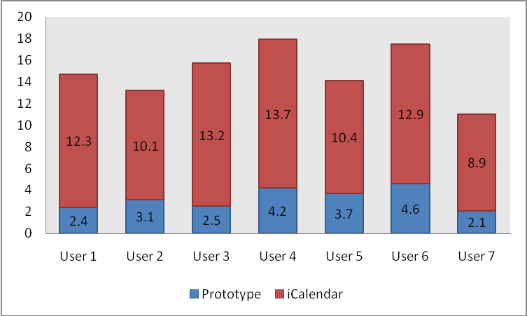
- Having a clearly marked “Add Event” button will help the user recognize it faster even if he/she is not familiar with the application.
Independent Variable: “Add Event” label name
Dependent Variable: Time it takes for a user to recognize it.

Condition 1: Use a “+” button on iCalendar.
Condition 2: Use an “Add Event” button on our Prototype.

Results in seconds:
Average time for Prototype users: 3.3 seconds
Average time for iCalendar users: 2.6 seconds.

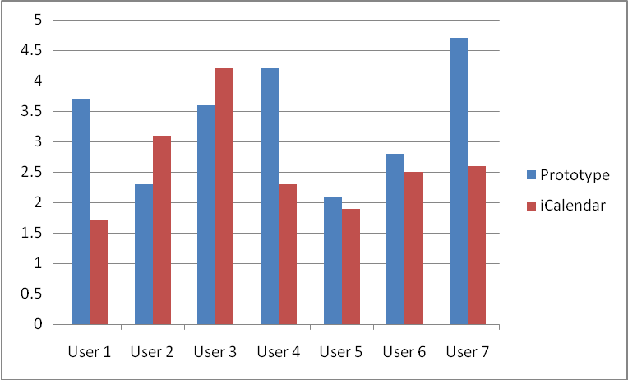
- Having the week view button clearly marked next to “Day”, “Month” and “Year” will help the user switch to Week view faster.
Independent Variable: The way of navigating to weekly view.
Dependent Variable: Time it takes a user to switch to weekly view.

Condition 1: Rotate Screen on iPhone to reveal Week view..
Condition 2: Have weekly view button displayed in the bottom left group of buttons.

Results in seconds:
Note: All of the iCalendar testers failed to find out how to navigate to the weekly view or thought that they are is no such screen on the phone.

Average time for a user to find out how to switch to week view:
Prototype users: 3.8 seconds
iCalendar users: 240+ seconds.

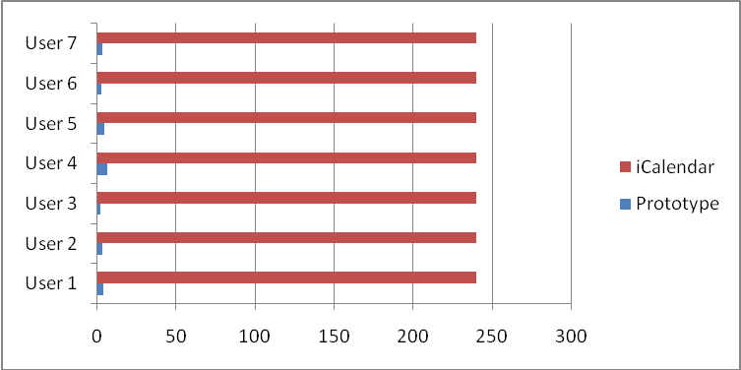
- Having the Categories visible on the top of the screen will help the user locate it and filter by category faster.
Independent Variable: The way of navigating to weekly view.
Dependent Variable: Time it takes a user to switch to weekly view.

Condition 1: Have a drop down list called “Calendars” (iCalendar)
Condition 2: Have all filters visible as buttons on the top of the screen (Prototype)

Results in seconds:
Average time for a user to find out how to only display social events (filter by “social” category):

Prototype users: 2.7 seconds
iCalendar users: 10.6 seconds.

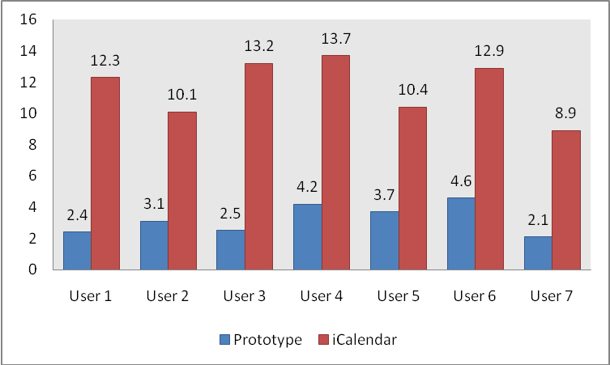
- In month view showing the number of events instead of showing one dot per event will help the user understand which days are the busiest faster.
Independent Variable: The way of navigating to weekly view.
Dependent Variable: Time it takes a user to switch to weekly view.

Condition 1: Showing one dot per event (iCalendar)
Condition 2: Showing the total number of events as an integer below the day number.

Results in seconds:
Average time it took for a user to figure out how many events there are on 2 days with 6 events each.
Prototype users: 3.22 seconds
iCalendar users: 11.64 seconds.

CITATIONS:
- Research Methods for the Behavioral Sciences, Frederick J. Gravetter &Lori-Ann B. Forzano, 2011, Cengage Learning BLA BLA need to add info
- Research Methods, Donald H. McBurney, Theresa L. White, Donald H. McBurney 2009

